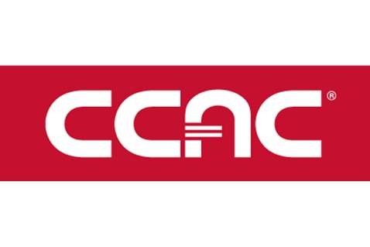
February 24, 2020

Community College of Allegheny County
8701 Perry Highway
Pittsburgh, PA 15237

Dear Dr. Thomas:

I am delighted to have the opportunity to review Professor Eric Darsow’s Fall 2019 faculty portfolio. I am in a rare position, as a reviewer, in that I have been both a student and a colleague of Professor Darsow’s, and even that is noteworthy: not every professor is capable of building a classroom community where someone could go from being their student to being their colleague, period, and usually not without some measure of awkwardness. Even among faculty at the graduate level, this is relatively rare, and at the community college level, it is almost unheard of. Professor Darsow treats his students with a tremendous amount of respect, and his classroom environment encourages students to learn both collaboratively and independently, as peers with their own valuable insights and skills. He is open and honest with his students, letting them know which activities are experimental—and he is fearless about experimenting in the classroom—and encouraging them to provide feedback and suggest improvements, which he then implements.
In my short time at CCAC, I have had several opportunities to collaborate closely with Professor Darsow: we co-taught two semesters of DAT-201 (Data Analytics 1); we worked together through the initial planning stages of ATE-252 (Explorations in Transportation Innovation); and he has led the development of the Data Analytics curriculum, which our department is revising this semester. He is a thoughtful and patient collaborator, always encouraging new approaches to teaching and providing helpful feedback and ideas.
After reviewing Professor Darsow’s portfolio, I can see that I still have a lot to learn from him—in particular, I am impressed by his creation of detailed, session-level learning outcomes and the helpful mapping between a first-level programming textbook and the assignments in its accompanying course. I also like the language around sharing of student work products in his syllabus, and I plan to implement something similar in my future Data Analytics courses (which are, in no small part thanks to Professor Darsow, built around hands-on projects, which are often designed to be expanded upon by students in future cohorts).
I appreciate the opportunity to review Professor Darsow’s portfolio, and I look forward to seeing his continued growth as an educator and technologist.

Best regards,

Coral Sheldon-Hess
Assistant Professor, Computer Information Technology & Data Analytics
CCAC North Campus

