CIS (050.3) Program Assessment: Student Instrument
Spring 2018 | Community College of Allegheny County

CCAC regularly assesses the skills of our students in each degree program at the college. As a student in CIT-111: Intro to Programming Java, you are being asked to complete this ANONYMOUS quiz-like assessment to help us improve the quality of education offered to our students.

Basic Information Gathering

1. Campus: __________________ Course Date/Times ________________________________

2. Have you declared your degree of study at CCAC to be an Associates Degree in Information Science (050.3)?

YES ___________

NO ___________ What is your declared program or certificate? _____________________

3. If you have taken any programming course prior to CIT-111, please list them in the box below and indicate where & when you took them (i.e. High School, 2015):

Instructions:

This assessment measures your ability to

- Comprehend a program flow chart and translate that information into a short application programmed in Java.
- “Paper compile” a program written in Java to generate an expected program output. This program consists of a single class with two methods.

The two rather short tasks in this assessment should take you no longer than 20-30 minutes. Your performance on these tasks will NOT impact your grade in CIT-111 in any way.

You are invited to use an Integrated Development Environment (IDE) such as Eclipse or NetBeans to complete task 1 ONLY. Task 2 should be completed by hand, on paper.

Please DO NOT consult any outside resources when completing this tool, including the Internet and your peers.

Thank you in advance for participating in this process.
Task 1: Programming from a flow chart

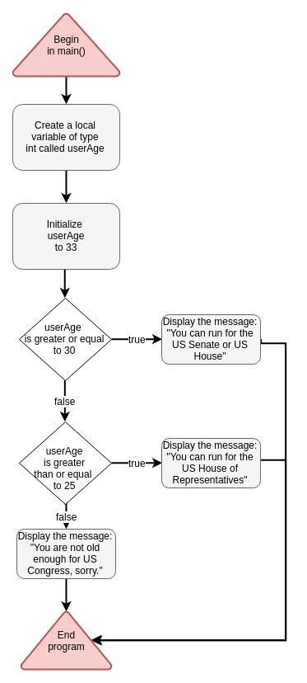
Instructions:

- Study the flow chart to the left and prepare to translate the flow into Java.
- Open a plain text editor or your favorite IDE such as NetBeans or Eclipse
- Create a class called OfficeElegibility and include a main() method.
- Code the program logic shown in the flow chart inside your main() method.
- When completed, test your code by changing the initial value of userAge.
- Comment your code as needed.
- Print your code onto paper and staple it to this assessment document.

Flow chart symbol Key:
Triangles represent program beginning and termination.
Rounded rectangles are general program events.
Diamonds represent decision points in the program, otherwise known as flow-of-control mechanisms.

Task 2: Paper compiling with method calls

Study the Java code below. This class called BasicMath carries out a few simple mathematical operations on two variables. Your job is to carefully track the value of each variable through the flow of the program and accurately generate the expected output of this program, which will consist of a single integer.

NOTE: After studying the code, please respond to the questions below. Showing any notes or scratch calculations will be useful for assessing your skill level. You are suggested to write your “best guess” abut the value of each variable.

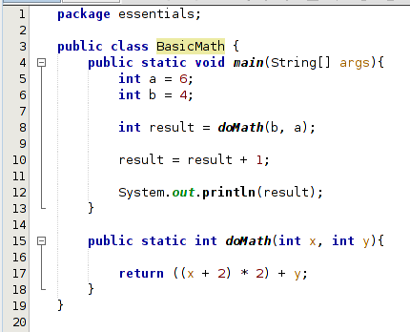
- What is the value of x at line 15?

- What is the value of y at line 15?

- What is the value of result AFTER line 8 has been executed?

- What is the value of result when it is printed to the console on line 12?

