CIS (050.3) Program Assessment: Teacher Guide
Spring 2018 | Community College of Allegheny County

This is a document for Java teachers administering the assessment instrument for the CCAC AS in Computer Information Science in CIT-111 during Spring 2018.

There is a companion document containing only the student handout linked here.

Our assessment focuses on the following program objective:

Program Objective 1: Apply core principles and practices of computing (Program completion objective #1)

Table of Contents
Section 1: Student Instrument 2
Section 2: Scoring Rubric for task 1 4
Section 3: Completed code for task 1: Flow chart translation into Java 5
Section 4: Scoring rubric for task 2: Paper compiling a basic method call 6
Section 5: Sample student response for task 2: Paper compiling a basic method call (rubric score: 4) 7

Section 1: Student Instrument
Task instructions:
This assessment measures your ability to
- Comprehend a program flow chart and translate that information into a short application programmed in Java.
- “Paper compile” a program written in Java to generate an expected program output. This program consists of a single class with two methods.
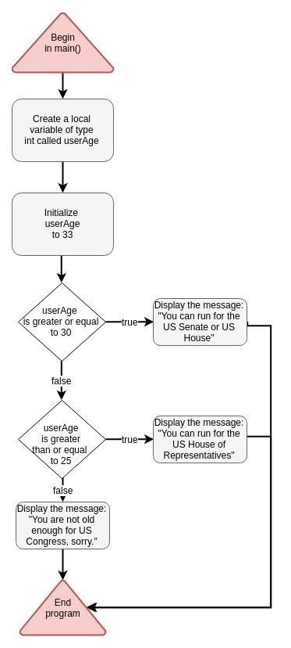
Task 1: Programming from a flow chart
- Study the flow chart below and prepare to translate the flow into Java.
- Create a class called OfficeElegibility and include a main() method.
- Code the program logic shown in the flow chart inside your main() method.
- When completed, test your code by changing the initial value of userAge.
- Comment your code as needed.
- Print your code onto paper and staple it to this assessment document.

Flow chart symbol Key:
Triangles represent program beginning and termination.
Rounded rectangles are general program events.
Diamonds represent decision points in the program, otherwise known as flow-of-control mechanisms.

Task 2: Paper compiling with method calls
Study the Java code below. This class called BasicMath carries out a few simple mathematical operations on two variables. Your job is to carefully track the value of each variable through the flow of the program and accurately generate the expected output of this program, which will consist of a single integer.

NOTE: After studying the code, please respond to the questions below. Showing any notes or scratch calculations will be useful for assessing your skill level. You are suggested to write your “best guess” abut the value of each variable.

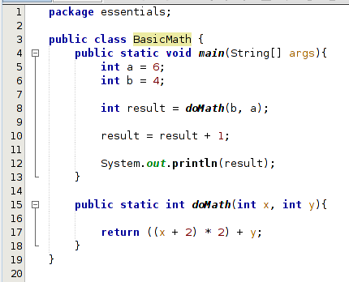
- What is the value of x at line 15?

- What is the value of y at line 15?

- What is the value of result AFTER line 8 has been executed?

- What is the value of result when it is printed to the console on line 12?

Section 2: Scoring Rubric for task 1 – Flow Charts

Scoring rubric for task 1: Flow chart translation into Java
Score | Criteria
0 – Not attempted | - No Java code was attached to the assessment or the code was in no ways related to the flow chart
1 – Insufficient skills | - Code would NOT compile  - A class with the appropriate name was created.  - Decision logic either not attempted or the attempt did not relate to the specification
2 – Below proficient | - Code WOULD compile  - Class and main() method were correctly created. Variables were correctly initialized.  - Decision logic is attempted but does not match specifcation’s requirements
3 – Proficient | - Code WOULD compile  - Decision logic is correctly implemented
4 – Advanced | - Code WOULD compile  - Decision logic is correctly implemented  - Exhibits one or more of these features:  - Java code reveals thought aimed at eliminating duplicate code  - Compactly implementing chained “if/else” statements  - Comments reveal grasp of the flow of the code  - Features of the code reveal thorough logic testing

Section 3: Completed code for task 1: Flow chart translation into Java

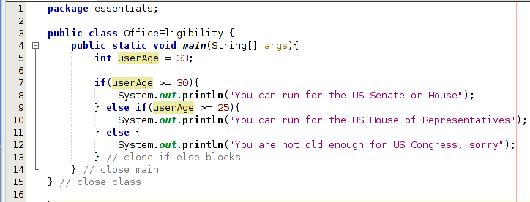

Section 4: Scoring rubric for task 2: Paper compiling a basic method call
Score | Criteria
0 – Not attempted | - 2 of the four questions were not answered.  - If one or two were answered, they were incorrect
1 – Insufficient skills | - The values for x and y were incorrectly identified (questions 1 and 2 are incorrect)  - No evidence reveals that the student was tracing the logic in doMath() through notes or marks on the paper.
2 – Below proficient | - The values for x and y at line 15 were incorrectly identified.  - The logic inside doMath() was not properly applied and did not properly get returned to line 8 but an attempt was made to calculate the return value.  - The final value of result at line 8 and 12 were incorrect.
3 – Proficient | - The values for x and y at line 15 were correctly identified.  - The logic within doMath() is correctly applied.  - The incrementing of result was improperly applied  - The program output was incorrect
4 – Advanced | - a and b were properly passed to doMath  - The math logic in doMath was properly executed  - doMath() returned the correct result  - The value of result was correct

Section 5: Sample student response for task 2:
Paper compiling a basic method call (rubric score: 4)


