Takata Airbag Replacement Case Study
Role Cards

Presenter Role A:
Ford motor company legal department

You work for Ford motor company's legal department and have been tasked with making this recommendation to your assigned audience by Herbert Norbert, Ford's Chief Counsel.

Espoused values:
- Accuracy of computations
- Avoiding legal liability which might induce future lawsuits
- Conservation of legal department resources

Your recommended recall priority:

Your rationale for the recommendation:

Presenter Role B:
National Highway Traffic Safety Association (NHTSA)
Analytics Team

You work for the US Federal Government's National Highway Traffic Safety Association (NHTSA) small analytics team. When the Takata Airbag's began failing and crash reports were filed with your agency, the director of NHTSA tasked your group of statistically minded federal government employees to analyze the existing data related to airbag tests to recommend to Ford Motors where the recall SHOULD begin.

According to your website:
NHTSA'S MISSION
Save lives, prevent injuries and reduce economic costs due to road traffic crashes, through education, research, safety standards and enforcement activity.

VISION
NHTSA aims to be the global leader in motor vehicle and highway safety.

CORE VALUES
NHTSA is dedicated to achieving the highest standards of excellence in motor vehicle and highway safety. The agency strives to exceed the expectations of the American traveling public through its core values of Integrity, Service and Leadership.

Your recommended recall priority:

Your rationale for the recommendation:

Audience Role 1:
Ford motor "C-Suite" executive team

You are one of the high-level executives at Ford Motors. You are part of the management of the entire operations of the company, and are tasked with choosing where to begin the recall of the airbags. The company's organizational structure is setup such that you are accountable to the board of directors which is elected by the shareholders. You, however, are not elected, but are full-time employees who oversee the actual management of the company.

Espoused values:
- Keeping your job
- Maintaining steady growth of your company's share value, since the shareholders are your ultimate boss
- Avoiding negative press about Ford Motors and their products

The 5-year stock value is displayed below:
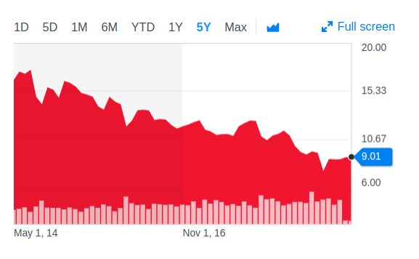

Presenter Recommendation:

Presenter's rationale for their choice:

Reaction to recommendation:

Audience Role 2:
State of Florida Consumer Protection Division

You work for the State of Florida's Consumer Protection Division of the office of Attorney General Ashley Moody. You have compiled records of malfunctioning airbags in Ford vehicles in your state and are reviewing the recommendations for the recall priorities of the Ford Motor Company.

You make recommendations to other elected officials in the State of Florida concerning purchases for the State of Florida's motor fleet, which is currently populated almost exclusively by Ford vehicles, some of which would be in line for replacement airbags.

From your website, your division's purpose is listed as follows:

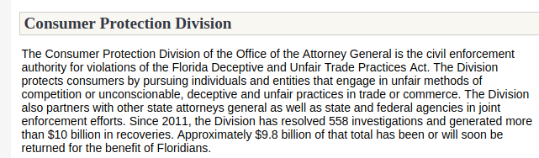

Presenter Recommendation:

Presenter's rationale for their choice:

Reaction to recommendation:

